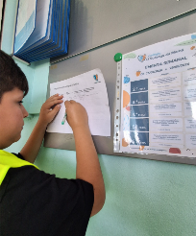
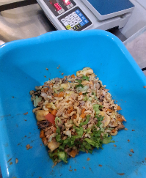
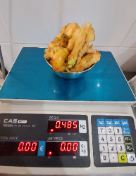
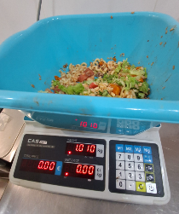
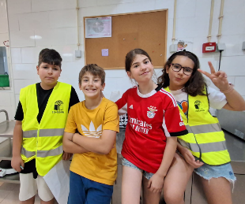
Análise (da ementa, que alimentos são mais visíveis no desperdício?)
____________________________________________________________________________________________________________________________________________________________________________________________________________________________________________________________________________________________________________________________________________________________________________________________________________________________________
Procedimentos/cuidados a ter na análise: (separação de lixos/frutas/comida)
________________________________________________________________________________________________________________________________________________________________________________________________________________________________________________________________________________________________________________________________________________
Cálculos necessários:

Conclusão:
________________________________________________________________________________________________________________________________________________________________________________________________________________________________________________________________________________________________________________________________________________________________________________________________________________________________________________________________________________________________________________________

O que vamos fazer para transmitir o que aprendemos e ajudar os nossos colegas a tomar consciência deste desperdício.
________________________________________________________________________________________________________________________________________________________________________________________________________________________________________________________________________________________________________________________________________________

